Case Study

Removing the D Word
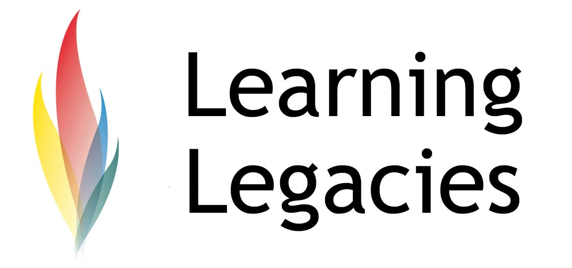

Removing the ‘D-word’: Arguing for the Use of the Word ‘Disabled’ in Paralympic Sport

One of the most exciting athletes to compete in the 2012 London Olympic Games is Oscar Pistorius. Pistorius, a double-amputee Paralympic multiple gold medallist, found himself at the centre of a legal maelstrom when the IAAF (International Association of Athletics Federations) pre-emptively banned him from competing in the Olympic Games in Beijing, if he made the qualifying time for the 400m Olympic event. The reason cited for the pre-emptive ban was a theorised competitive advantage that Pistorius possessed over able-bodied athletes, as a result of his use of prosthetic legs (carbon fibre blades nicknamed ‘cheeta’s). Pistorius’s camp responded by contesting the ban, citing a lack of scientific research with which to back up their claims of an unfair advantage.

The case was taken to appeal at the Court of Arbitration for Sport, which ruled in favour of Pistorius. Research identified the many disadvantages associated with the use of prosthetics, including the fact that Oscar could not gain any acceleration when pushing off starting blocks (as an able-bodied athlete with calf muscles and an Achilles tendon can), putting him at a significant disadvantage and requiring him to build up speed slowly from the start of the race as a result. Interestingly, the fact that Pistorius increased his speed in this way was cited as supporting evidence of a competitive advantage by the IAAF.

One might also question the fact that prosthetic limbs offer disabled athletes an advantage over their able-bodied counterparts, as only Oscar has managed to rise to the heights of Olympic and World Championship competition (despite countless other disabled sprinters using the same technology). One might also observe the fact that Pistorius smashed the existing disabled 400m Paralympics record only months after he was introduced to athletics, and that he progressed to winning Gold medals in the 100m, 200m, and 400m events in successive Paralympic Games.

Pistorius was not able to qualify for the Beijing Olympics, but the London Games remained very much in his sights, both in terms of competing in the 400m event in the Olympic and Paralympic Games. By recording a personal best of 45.07 seconds earlier this year (2011) in Ligano, Italy, Pistorius successfully qualified for the Games, in addition to qualifying for the World Championships in South Korea in August, 2011 (in fact, this qualifying time would have earned him 5th place in the Beijing Olympic Games 400m vent). Qualification for the World Championships meant that Pistorius has made history, even before he sets foot on the Olympic running track.

Redefining Disability?

One might argue that Pistorius is redefining the concept of the ‘able-bodied’ and the ‘disabled’ athlete. He famously states that ‘You're not disabled by the disabilities you have, you are able

by the abilities you have’ and also commented that he is not disabled – he just doesn’t have any legs. Indeed, Pistorius has been a key sportsman all his life, excelling in waterpolo, cricket, tennis, triathlons and Olympic wrestling and boxing and rugby, before gaining an introduction to athletics as a means of rehabilitation for an injury picked up in rugby.

‘Disability’ can be defined as ‘Having a physical or mental condition that limits movements, senses or activities’.

If Oscar Pistorius has reached the highest echelons of sport, ranking a notional 5th in the Beijing Olympics according to his personal best, qualifying as one of the fastest men in the world to compete in the London Olympic Games and winning countless Paralympic Gold medals, does he still really fit into a category that we would refer to as ‘disabled’? After all, he is clearly more able than most of the world’s population when it comes to running the 400m sprint. He does not have lower legs but this does not seem to have limited his activities.

If one extends the concepts of disability to consider not only Oscar’s double-amputee status, but also his strength of character in mounting a legal challenge against the most powerful athletics federation in the world, one might argue that there remains little room to conceptualise him as disabled.
Sponsorship

Case Study

Removing the D Word

WOMENS PARTICIPATION IN THE OLYMPIC GAMES
One might consider Oscar Pistorius to be, simply, a champion, and to dispense with the label of disabled or able-bodied. Sponsors certainly feel that way, with lucrative endorsements (such as Nike) professing the power of an athlete who has crossed the boundary of able-bodied or disabled athlete, to simply be a great athlete who is also a great ambassador for their brand
Further Information
- CNN.com – The Bullet in the Chamber: Interview with Oscar Pistorius
http://edition.cnn.com/2011/09/30/sport/olympics-pistorius-london-2012/index.html
Discussion
- Research the case of Natalie du Toit. What parallels do you observe with her sporting achievements and those of Pistorius?
- Is the term ‘disability’ still relevant, and, if so, might it be considered applicable only in certain contexts, such as in employment law?
- Do you feel that the term ‘disabled’ and ‘able-bodied’ might be replaced or modified when we are discussing elite athletes?
- Can you find any other cases of elite athletes with a disability who compete against able-bodied athletes? Despite winning the CAS appeal, many people still comment that Pistorius has an advantage. Do you think that these beliefs stem from a lack of knowledge of the evidence that supports the appeal itself, or is it a result of discrimination or other factors

Case Study

Removing the D Word

WOMENS PARTICIPATION IN THE OLYMPIC GAMES

Case Study

Removing the D Word

WOMENS PARTICIPATION IN THE OLYMPIC GAMES

This resource was produced as part of the 2012 Learning Legacies Project managed by the HEA Hospitality, Leisure, Sport and Tourism Subject Centre at Oxford Brookes University and was released as an Open Educational Resource. The project was funded by HEFCE and part of the JISC/HE Academy UKOER programme. Except where otherwise noted above and below, this work is released under a Creative Commons Attribution only licence.

Exceptions to the Licence
The name of Oxford Brookes University and the Oxford Brookes University logo are the name and registered marks of Oxford Brookes University. To the fullest extent permitted by law Oxford Brookes University reserves all its rights in its name and marks, which may not be used except with its written permission. The JISC logo is licensed under the terms of the Creative Commons Attribution-Non-Commercial-No Derivative Works 2.0 UK: England & Wales Licence. All reproductions must comply with the terms of that licence.

The Higher Education Academy logo is owned by the Higher Education Academy Limited and may be freely distributed and copied for educational purposes only, provided that appropriate acknowledgement is given to the Higher Education Academy as the copyright holder and original publisher.

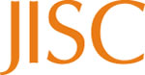

Reusing this work
To refer to or reuse parts of this work please include the copyright notice above including the serial number. The only exception is if you intend to only reuse a part of the work with its own specific copyright notice, in which case cite that.

If you create a new piece of work based on the original (at least in part), it will help other users to find your work if you modify and reuse this serial number. When you reuse this work, edit the serial number by choosing 3 letters to start (your initials or institutional code are good examples), change the date section (between the colons) to your creation date in ddmmyy format and retain the last 5 digits from the original serial number. Make the new serial number your copyright declaration or add it to an existing one, e.g. ‘abc:101011:011cs’.
If you create a new piece of work or do not wish to link a new work with any existing materials contained within, a new code should be created. Choose your own 3-letter code, add the creation date and search as below on Google with a plus sign at the start, e.g. ‘+tom:030504’. If nothing comes back citing this code then add a new 5-letter code of your choice to the end, e.g.; ‘:01lex’, and do a final search for the whole code. If the search returns a positive result, make up a new 5-letter code and try again. Add the new code your copyright declaration or add it to an existing one.

